# **Introduction**

This document describes the Bocada HP Data Protector Rest Plug-in.

The Bocada HP Data Protector Rest Plugin is primarily used to bring backup job data into the Bocada database through communication with HP Data Protector Rest API.

To HP Data Protector API works we will need to setup two modules:

* Data Protector Cell Manager - responsible to the backup control and to provide the Rest API.
* Reporting Server – Responsible to provide a data source about different aspects need during the data mining of Bocada Data Collection.

**Supported Collection Types**

The plug-in currently supports the following collection types:

|  |  |  |
| --- | --- | --- |
| **Collection Type** | **Supported** | **Description** |
| Backup | ✓ | Collects transactional details about backup, duplication, and restore jobs. Example metrics include start times, durations, bytes, files, errors, etc. |
| Storage |  | Collects point-in-time inventory information. Example metrics include total recoverable gigabytes (storage), media volume count, media volume status, etc. |
| Policy |  | Collects and stores information on policy attributes, schedules, storage units, storage groups, storage lifecycle policies, and clients. |

**1.0 Setting up HP Data Protector Rest Plugin**

The setting up process will take the following steps.

**1.1:** Setting Up Cell Manager API

**1.2:** Installing Report Server and linking it to the Cell Manager

**1.3:** Linking Data Protector Cell Manager with Reporting Server

We made a simplified manual, but you can check all the process in the official document at:

<https://docs.microfocus.com/doc/Data_Protector/11.00/RESTAPIReference>

**1.1 Setting Up Cell Manager API**

We need to set up a new user to be used on the API. To do that we need to create a new user to be used by the API.

* Creating a new user
  + Open the Data Protector Manager
  + Select **Users** on the top combo button
    - Click with the right click of the mouse to **Add a new user**

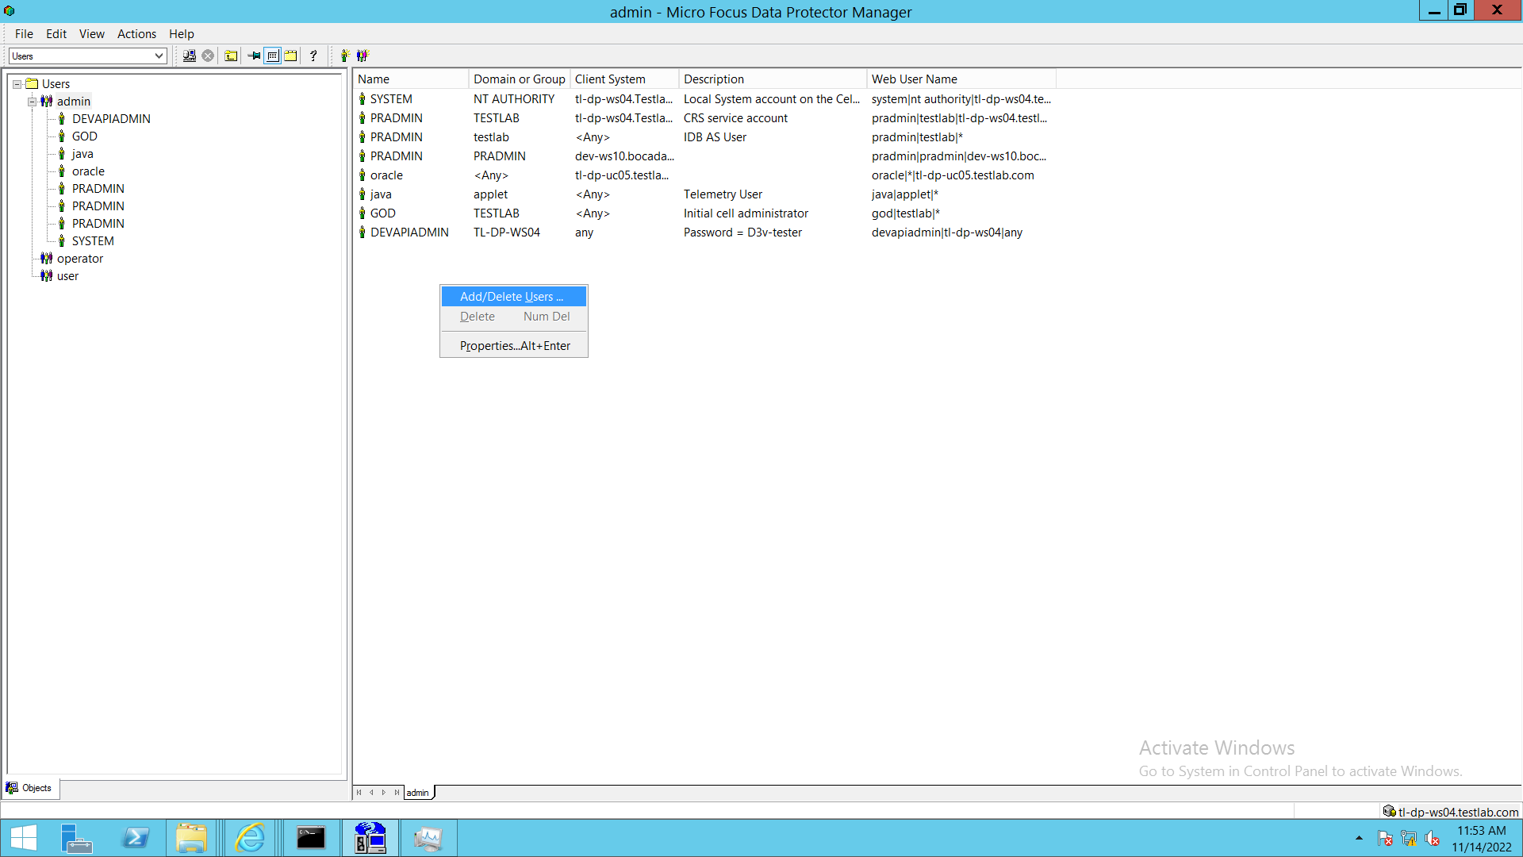

* Fill the data in the User form. In our case we made it for Windows.
  + Type
    - Windows
  + Group/Domain
    - TL-DP-WS04
      * Get it from the Windows Account Manager

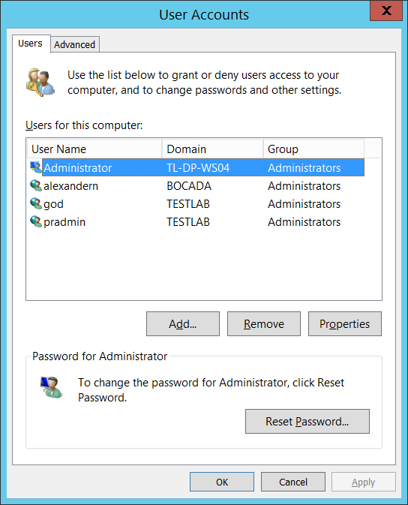

* + Client
    - E.g.: any
    - We specified any to consider all the clients covered by the Cell Manager
  + Password
    - D3v-tester
      * <Choose yours>
  + Confirm password
    - D3v-tester
      * Repete it

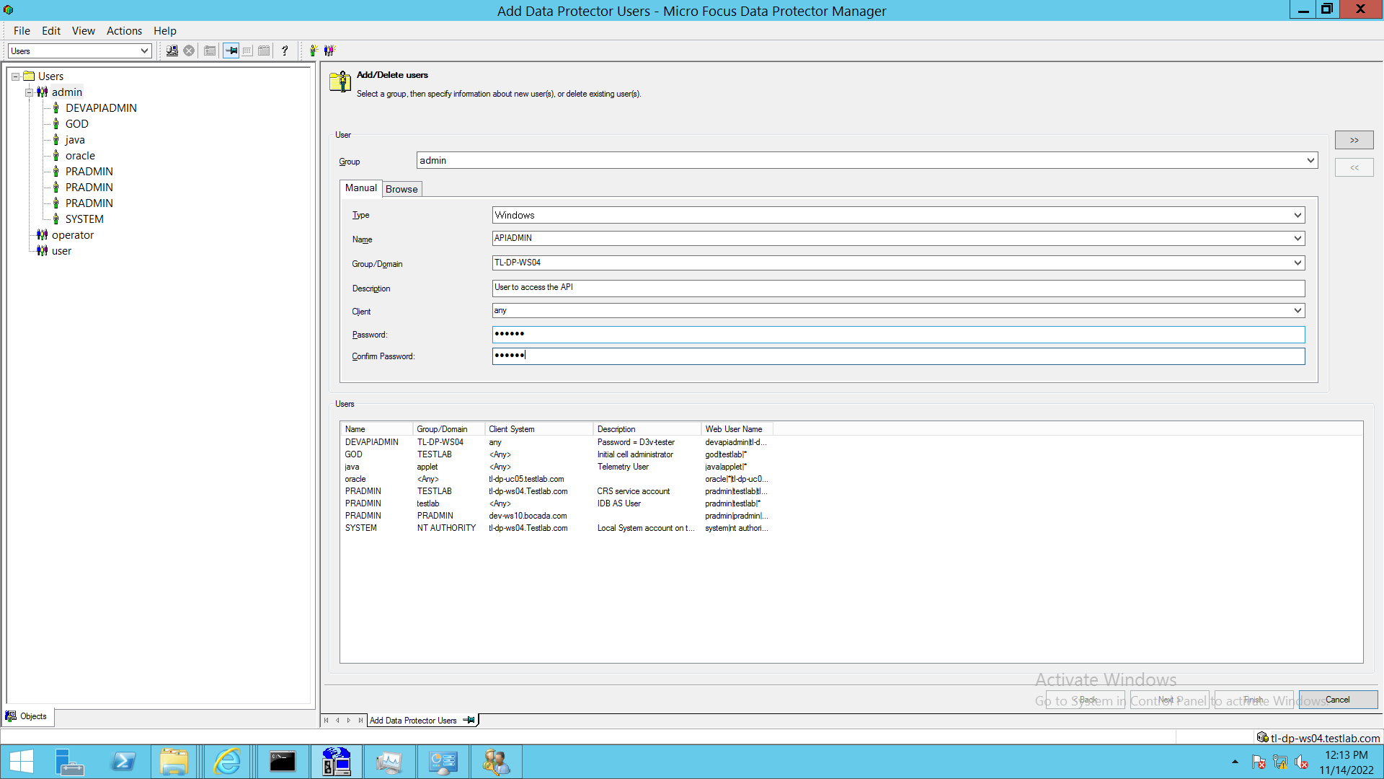

* + - Click on the top right button - **>>**
      * **Accept the warning dialog saying that the client any does not exists.**
    - After click on the button **Finish** on the bottom

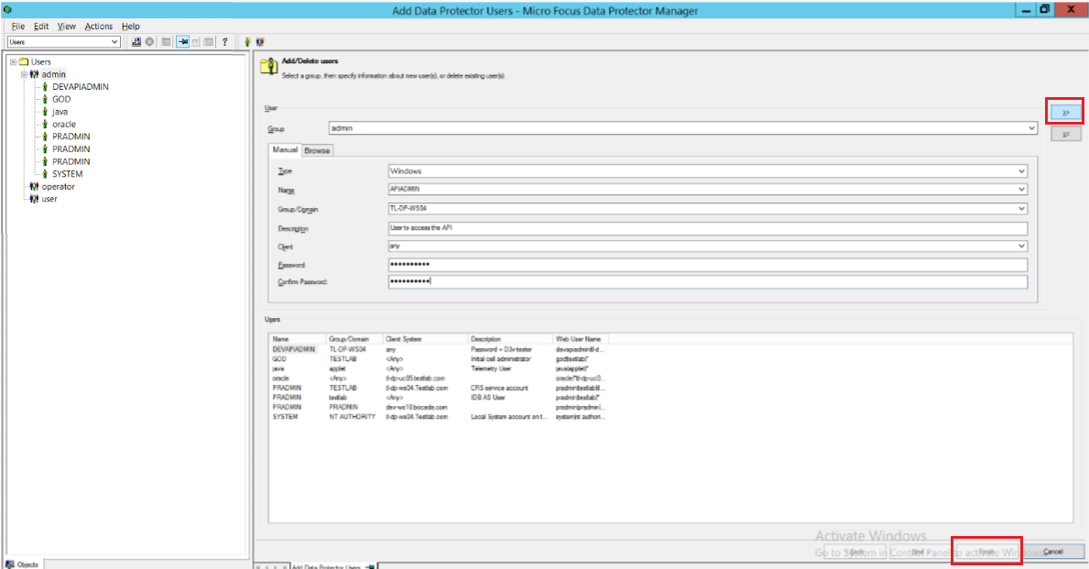

* + Now you will see the new user under **admin** category

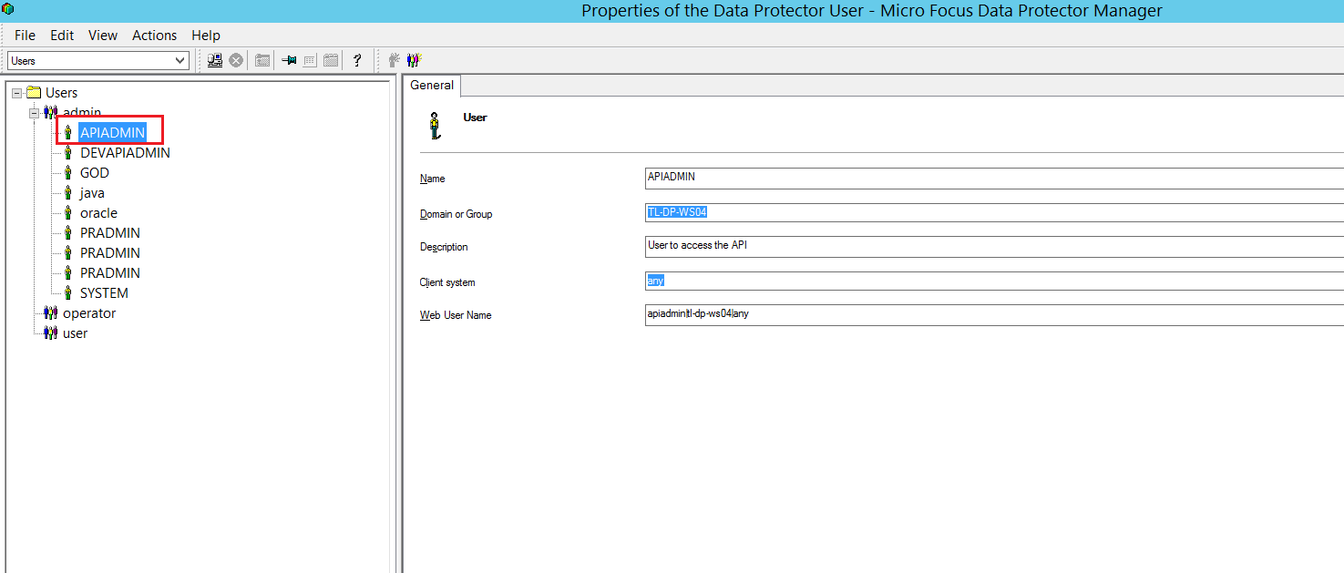

* + **Checking if it works**
    - In our example here, after creating the user, you can check the status of the API using the Test Connection functionality in the Data Collection section of Bocada Software

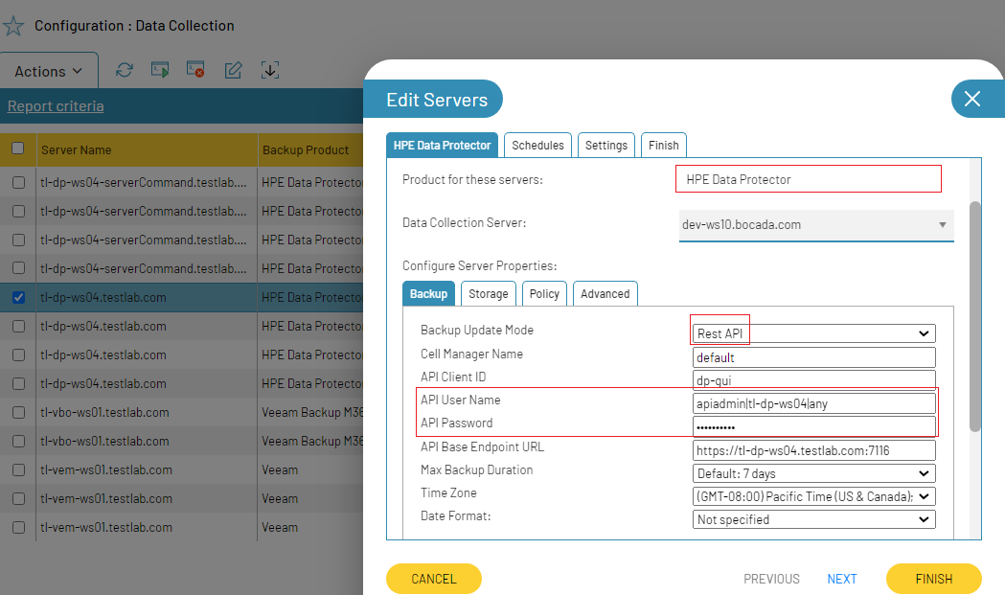

* + - **Server Name:**
      * E.g.:tl-dp-ws04.testlab.com
      * It is the identification name to your Data Collection. Can be anything that suits better for you
    - **Product for these servers**
      * HPE Data Protector
    - **Backup Update Mode**
      * Rest API
    - **Cell Manager Name**
      * E.g.: tl-dp-ws04.testlab.com
      * It corresponds to the server name of the Data Protector Cell Manager
      * **Default:** it will use the Server Name content
    - **API Client Id:**
      * **dp-gui**
      * It’s a constant.
    - **API Username**
      * E.g.: devapiadmin|tl-dp-ws04|any
      * You must concat the three information:
        + <user name>|<user group>|<client name>

User name:

Devapiadmin

Windows User name

TL-DP-WS04

Client name

any

We put **any** during the user creating in HP Data Protector.

* + - **API Password**
      * E.g.: D3v-tester
      * It’s the password that you used during the user creating in Data Protector Cell Manager
    - **API Base Endpoint URL**
      * E.g.: <https://tl-dp-ws04.testlab.com:7116>
      * It’s the same server where HP Data Protector is installed

**1.2 Installing Report Server and linking it to the Cell Manager**

The API from Data Protector need the Report Server running for required endpoints used in the data mining of Bocada’s software

You can see the official source of information at: <https://docs.microfocus.com/doc/Data_Protector/11.00/InstallReportsServer>

Another option is the simplified manual below:

**Prerequisites**

The prerequisites for installing a reporting server is the same as that of a Cell Manager. If you are installing the Reporting Server on a Linux server, the rsdb user must be created and Open file limits must be adjusted for rsdb and root user.

To allow import of the Reporting Server,

* + open the Reporting Server port (8443 default);
  + and Cell Manager application server port (7116 default);
  + and Report Server database communication (5432 default);

in the firewall.

**Installing**

1 – Download the installer file at

* **Server**
  + tl-dp-ws04.testlab.com
* **Path**
  + E:\ProgramData\OmniBack

2 - After copied start the installation at the subdirectory

* **Path**
  + i386\setup.exe

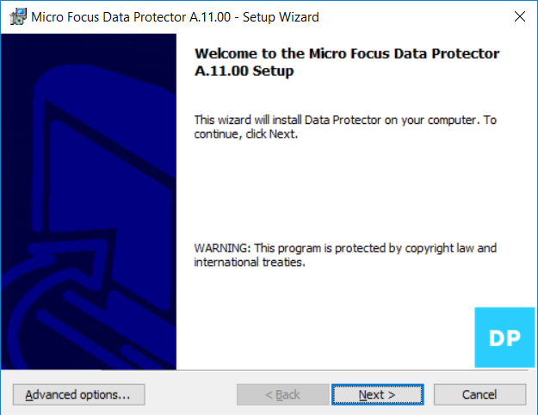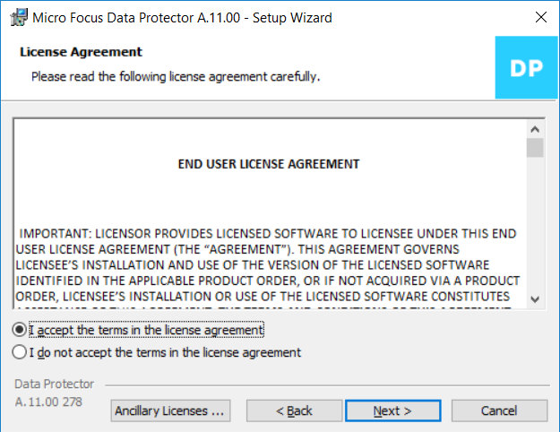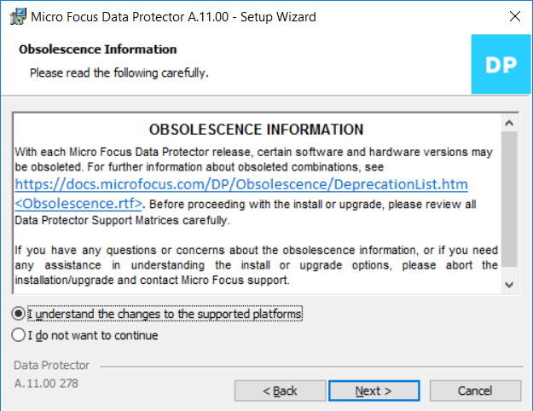

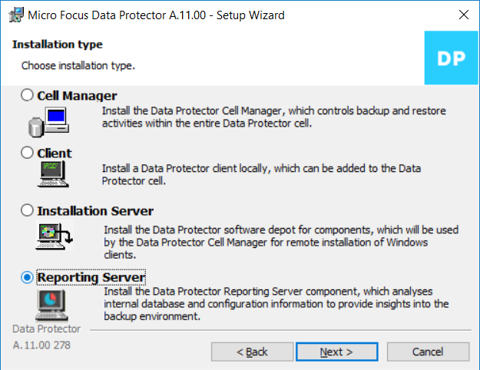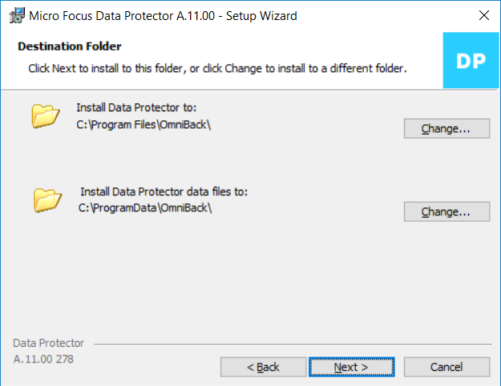

* **Set a server user**

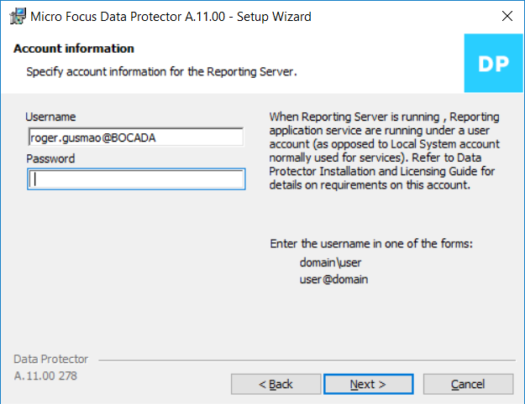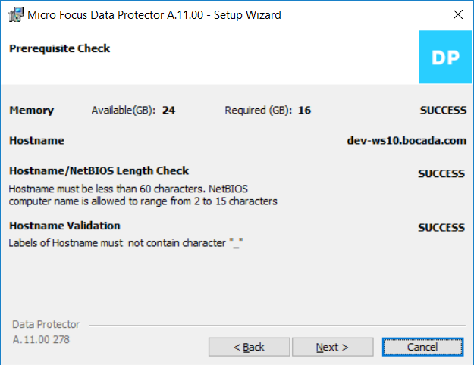

* **Set a user to Report Server**
  + **Username:**
    - E.g.: pradmin
  + **Password**
    - E.g.: Testing_2022
  + **Port**
    - E.g.: 8443
    - Put the communication UDP/TCP over 8443 on your firewall
  + **Reporting Server database port**
    - E.g.: 5432
    - Put the communication UDP/TCP over 5432 on your firewall

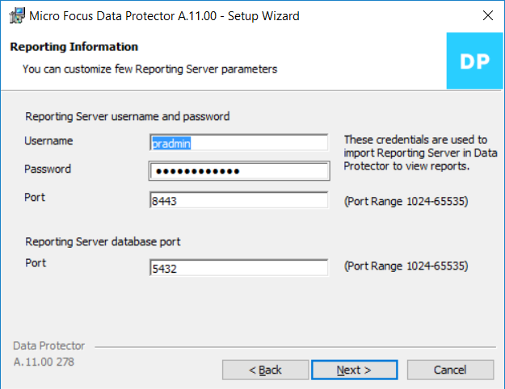

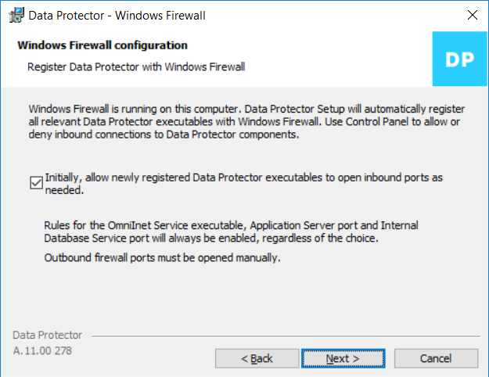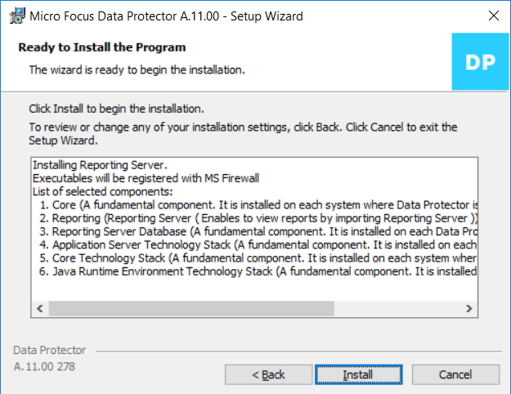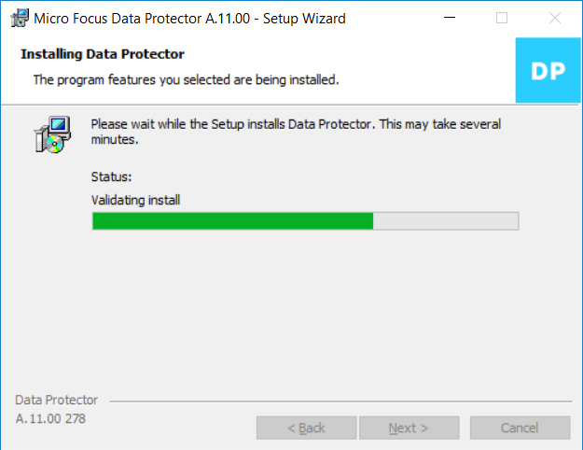

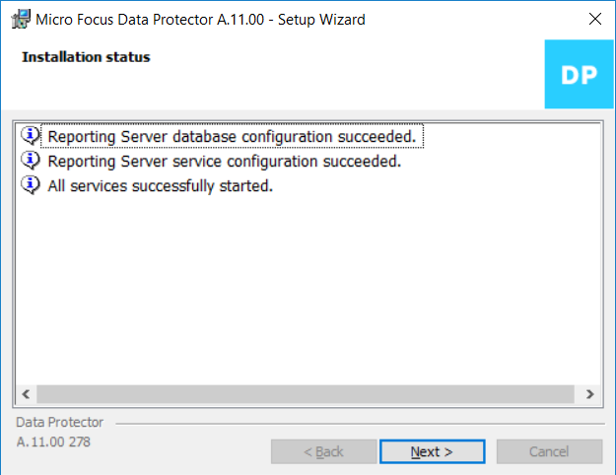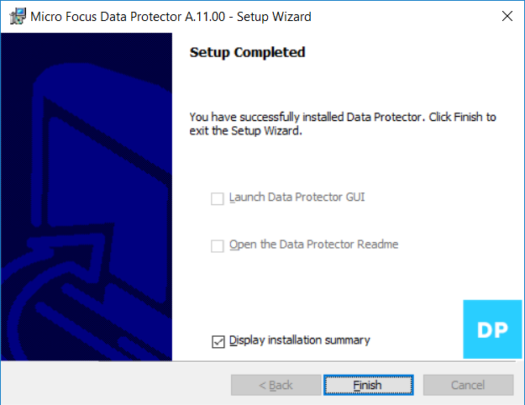

**1.3: Linking Data Protector Cell Manager with Reporting Server**

Now we will set up the Data Protector Cell Manager to communicate with the installed Report Server

* Open Data Protector and select Home context in the combo button

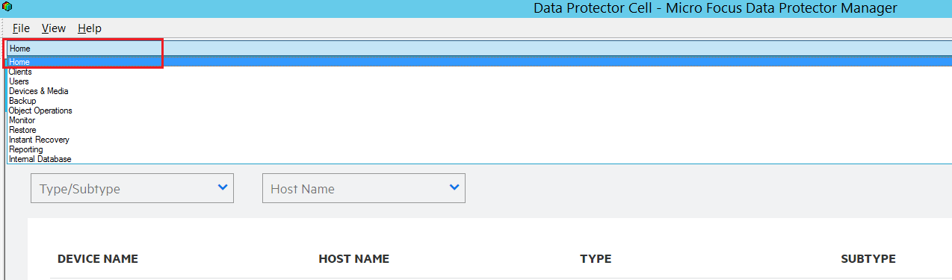

* Click on Launch Report Wizard blue button

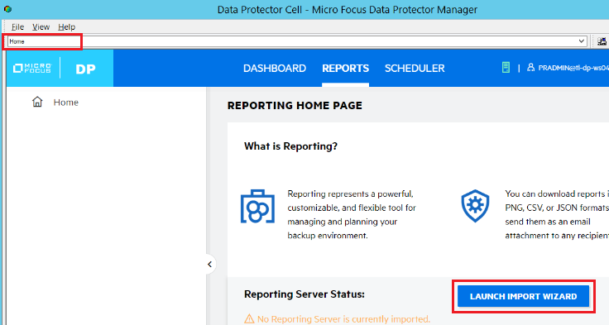

* Set the user API credential used during the installation.
  + **Hostname**
    - E.g.: dev-ws10.bocada.com
    - It’s the server name where the Report Cell Manager was installed
  + **Username**
    - Eg.: pradmin
    - It’s the user setted up during
  + **Password:** Testing_2022

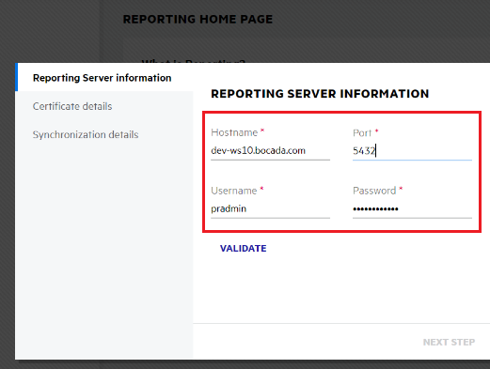

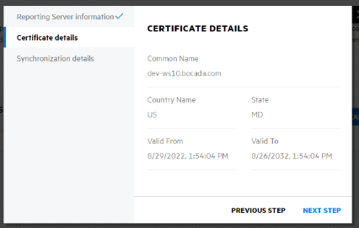

* **Done!** Now select Home again on the top combo button and open the tab **Reports.** You will see the respective status.

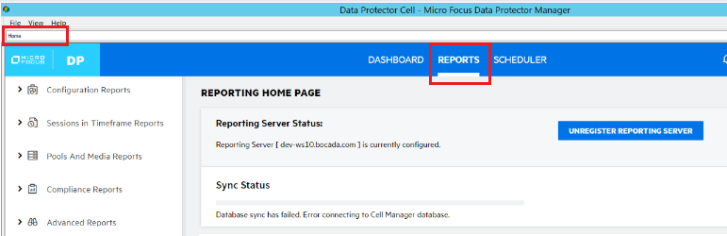

# **Backup Data Collection**

## **Port Communication**

The following ports are required to be open between any server running the Bocada Data Collection Service (DCS) and each Data Protector Cell Manager:

|  |  |  |  |  |  |
| --- | --- | --- | --- | --- | --- |
| **Data Protector Versions** | **Bocada** **Data Collection** | **Protocol**  **or**  **Daemon** | **Default Port** | **Direction** | **Notes** |
| 11+ | Backup | HTTP | 7116 | Bi-directional | Required for Cell Managers |

All ports must be opened bi-directionally.

For the following cases the ports are related between the communication of Report Server and Data Protector Cell Manager:

|  |  |  |  |  |  |
| --- | --- | --- | --- | --- | --- |
| **Data Protector Versions** | **Bocada** **Data Collection** | **Protocol**  **or**  **Daemon** | **Default Port** | **Direction** | **Notes** |
| 11+ | Backup | HTTP | 7116 | Bi-directional | Required for Report Server |
| 11+ | Backup | UDP/TCP | 8443 | Bi-directional | Required for Report Server |
| 11+ | Backup | UDP/TCP | 5432 | Bi-directional | Required for Report Server |

All ports must be opened bi-directionally.

## **Bocada Server Properties (Backup)**

To setup the Rest API version of Data Collection Backup select:

* **Server Name:**
  + **E.g.:** tl-dp-ws04.testlab.com
  + It is the identification name to your Data Collection. Can be anything that suits better for you
* **Product for these servers**
  + HPE Data Protector
* **Backup Update Mode**
  + Rest API
* **Cell Manager Name**
  + **E.g.:** tl-dp-ws04.testlab.com
  + It corresponds to the server name of the Data Protector Cell Manager
  + **Default:** it will use the Server Name content
* **API Client Id:**
  + **dp-gui**
  + It’s a constant. We will remove it from the input in the next versions
* **API Username**
  + devapiadmin|tl-dp-ws04|any
  + You must concat the three information:
    - <user name>|<user group>|<client name>
      * User name:
        + Devapiadmin
      * Windows User name
        + TL-DP-WS04
      * Client name
        + any

We put **any** during the user creating in HP Data Protector.

* **API Password**
  + D3v-tester
  + It’s the password that you used during the user creating in Data Protector Cell Manager
* **API Base Endpoint URL**
  + <https://tl-dp-ws04.testlab.com:7116>
  + It’s the same server where HP Data Protector is installed

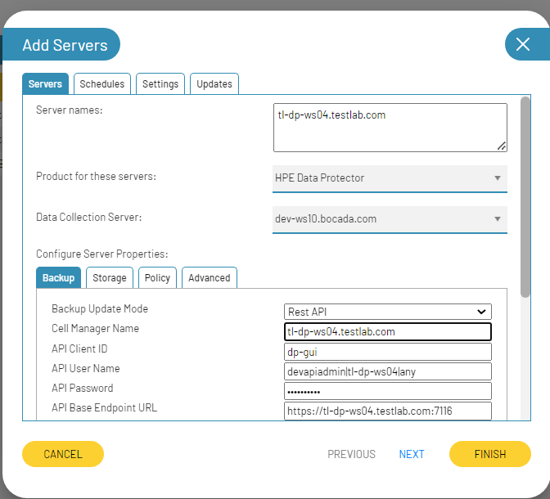

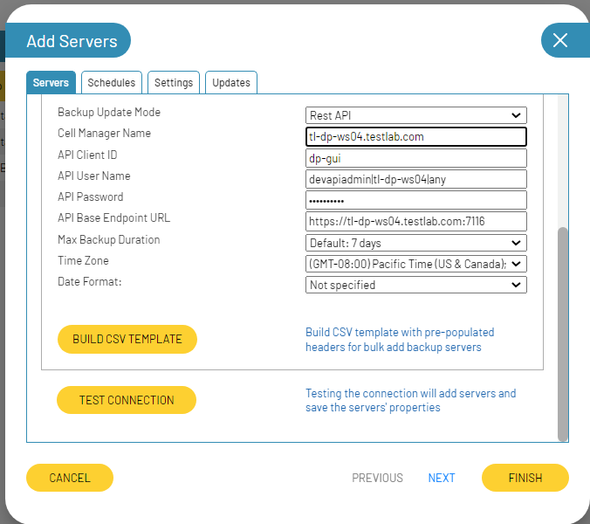

## **Additional Server Properties**

#### ***Max backup duration***



Set this property to the longest duration backup job on the DP Cell Manager. The larger the value, the more impact it will have on the performance of the Bocada updates.

*****Time Zone*****

Select the time zone where Data Protector Cell Manager resides. This setting ensures times are displayed consistently in environments that span multiple time zones. Data extracted from the server is converted to Coordinated Universal Time (UTC) then to the time zone chosen in report criteria.